1. Create a PSM

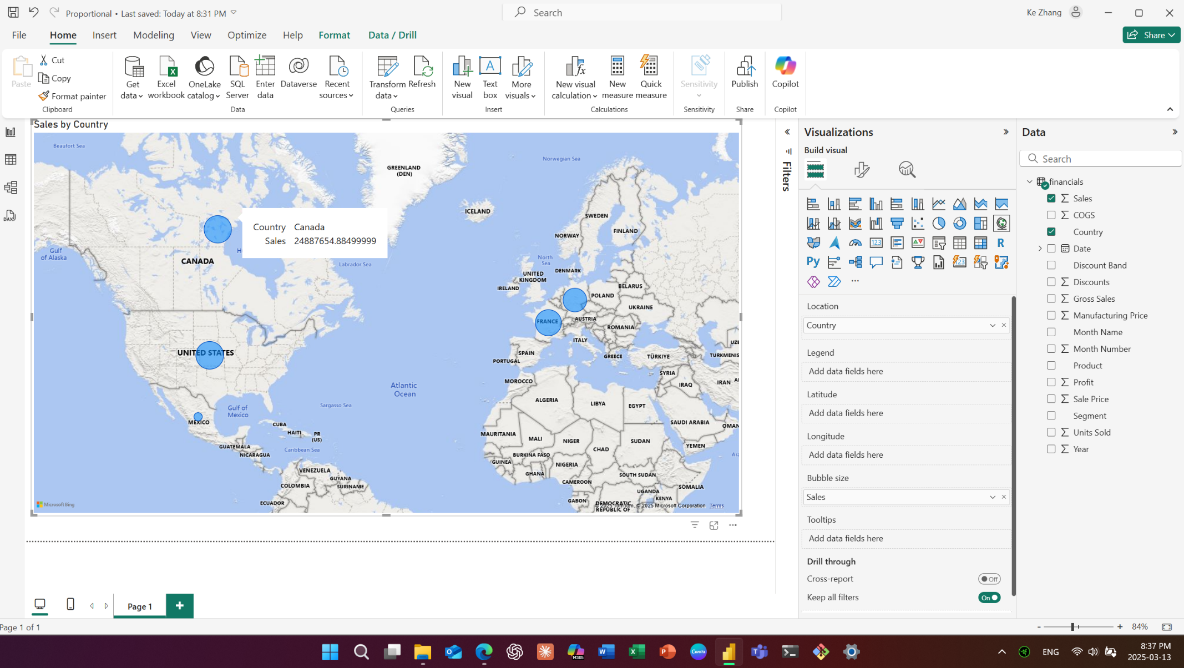

2.1 Choropleth Maps

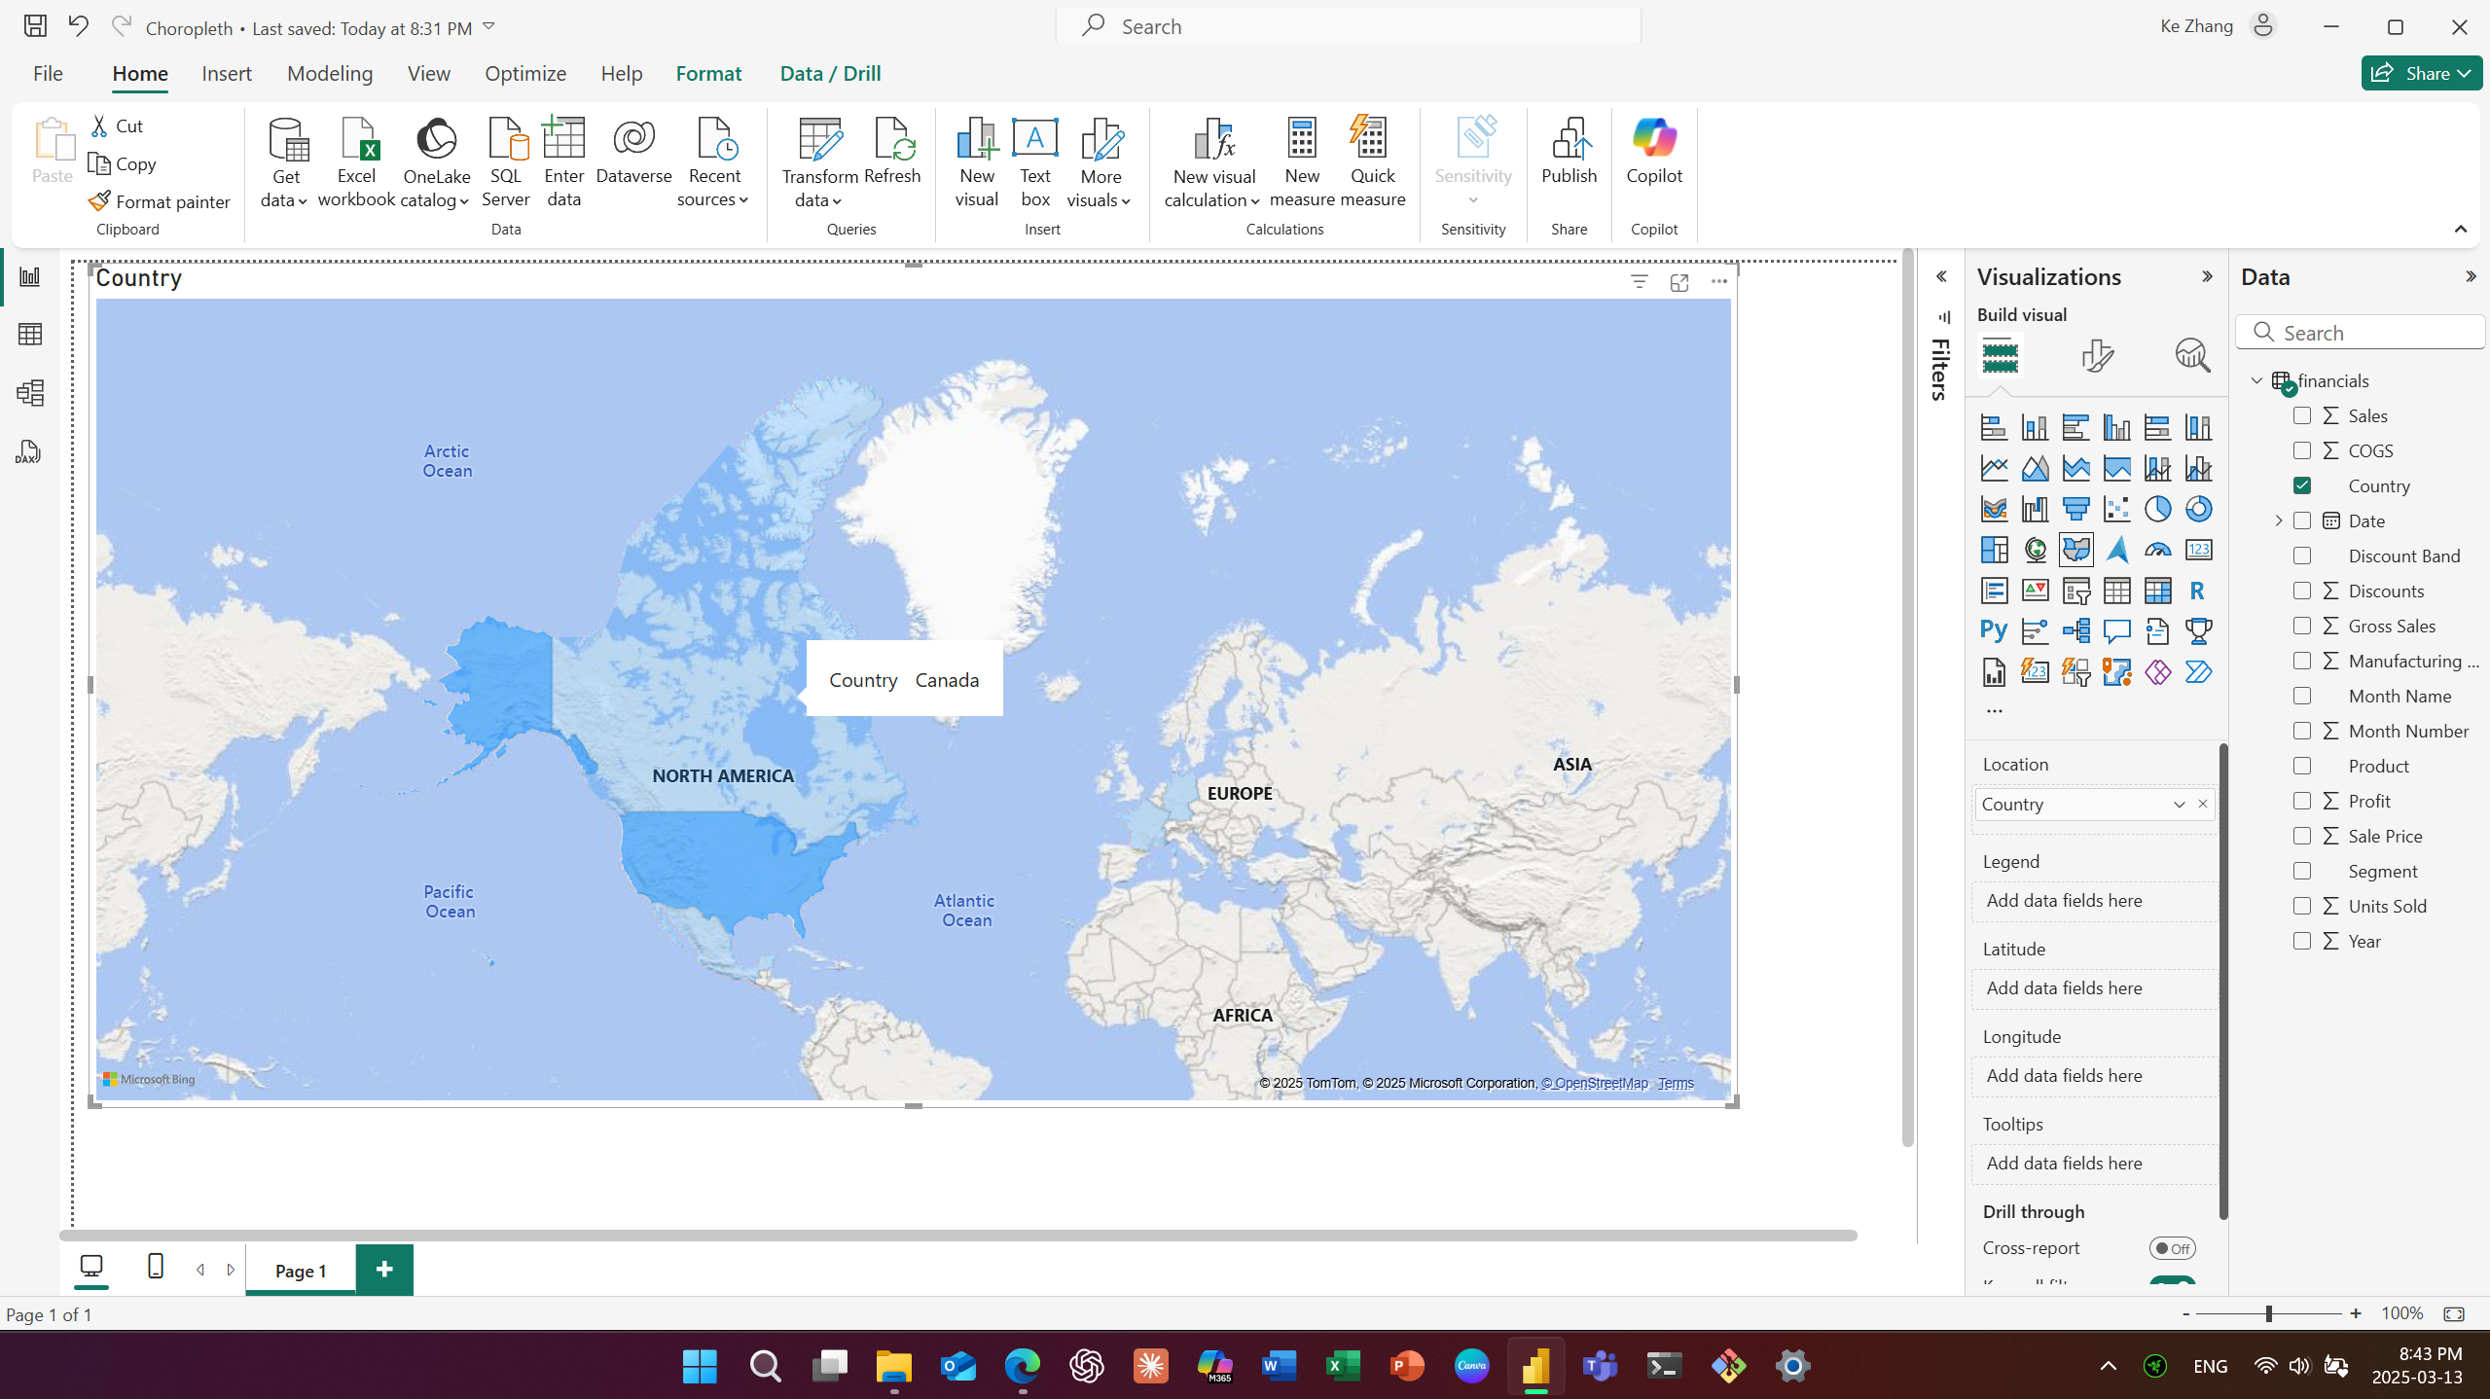

2.2 Add Conditional Formatting to a Choropleth Map

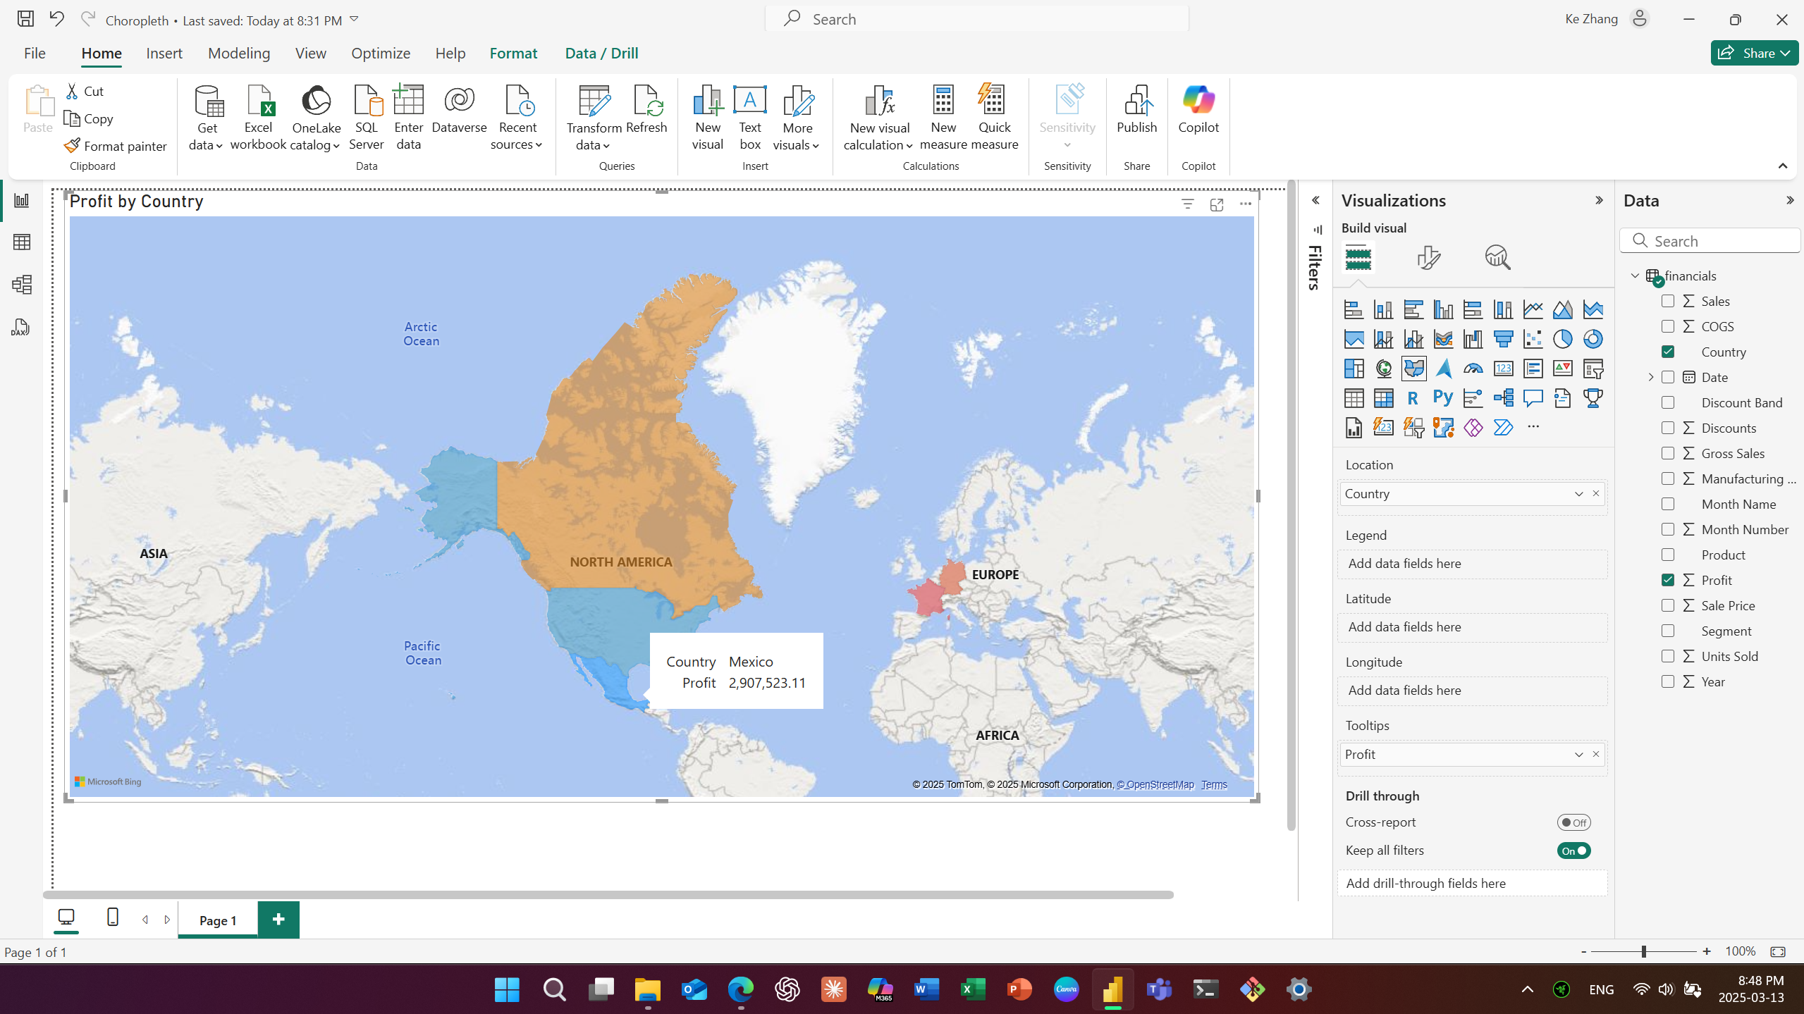

3.1 The SUM Function - Add all Numbers in a Column

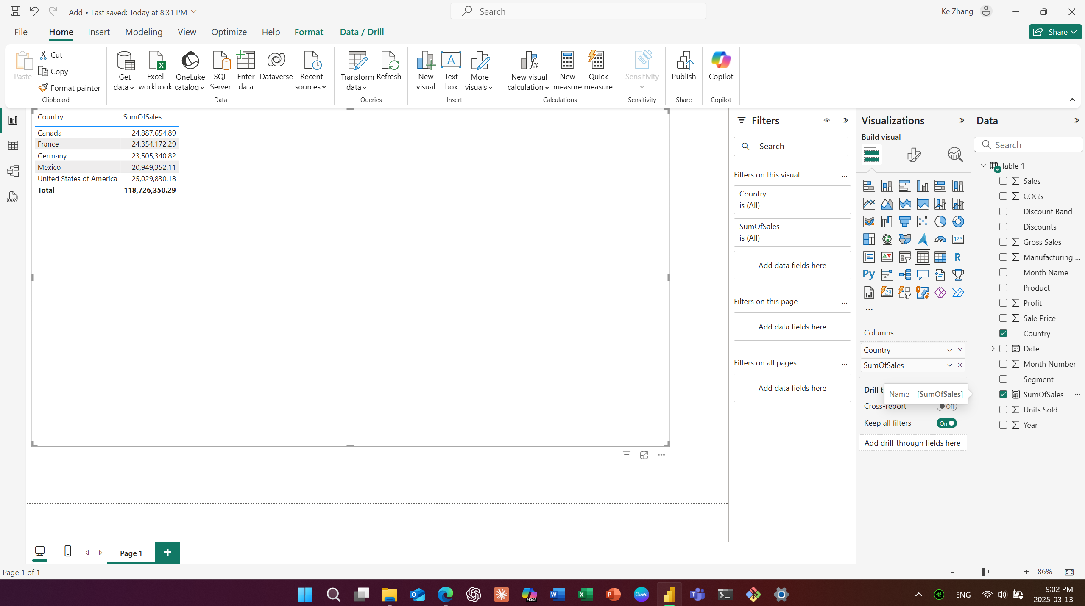

3.2 The DIVIDE Function - Perform Division

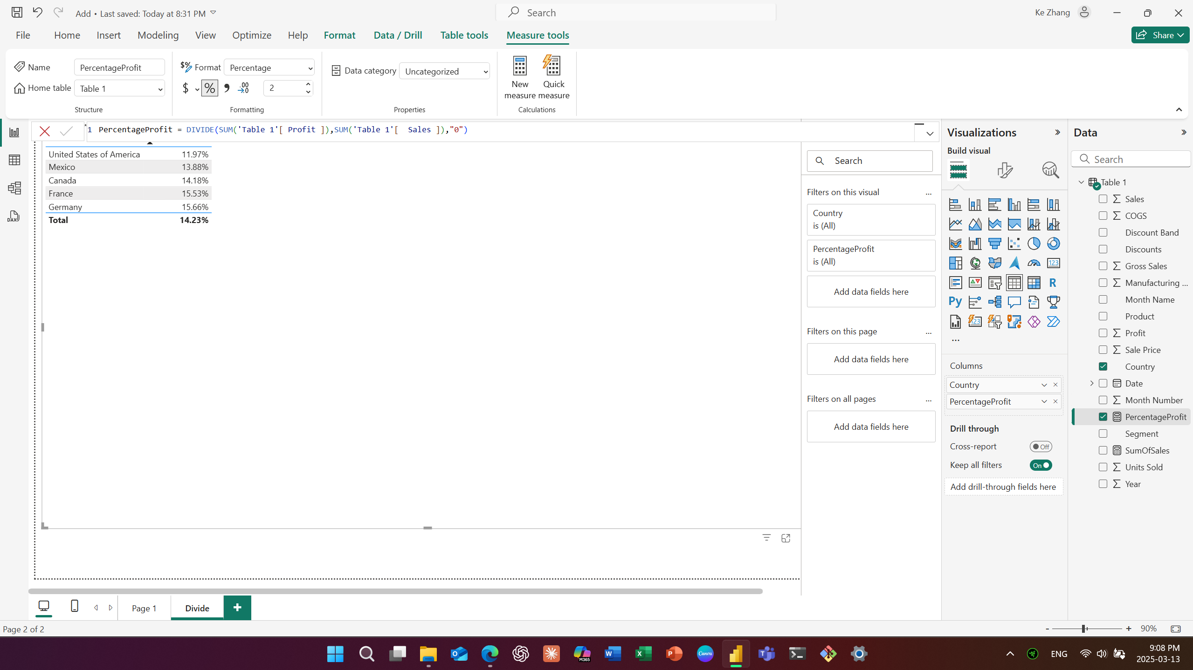

3.3 - Check a Condition

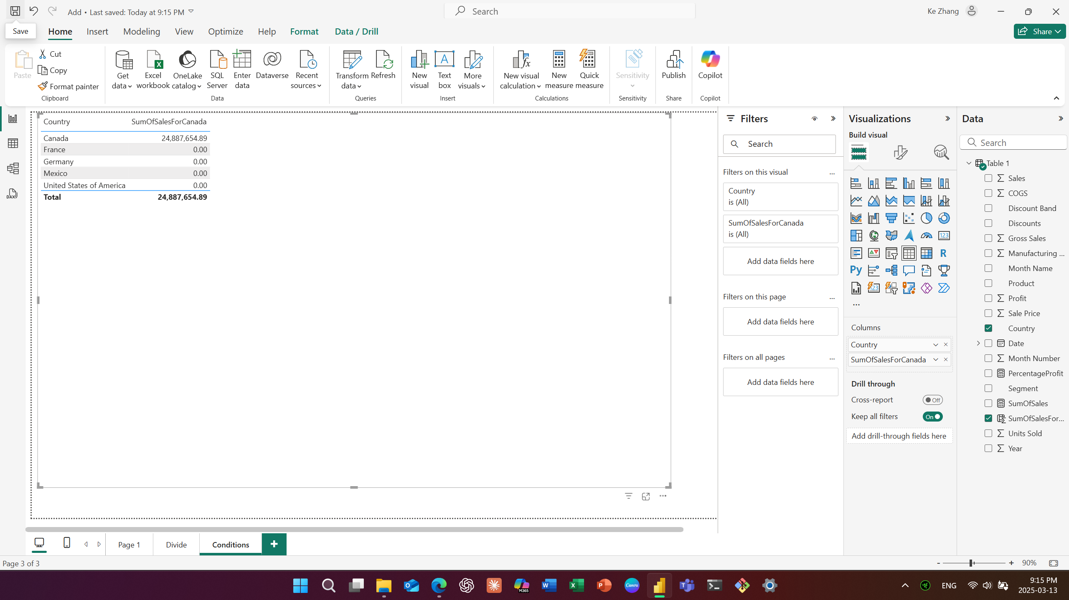

3.4 Count the Number of Cells in a Column

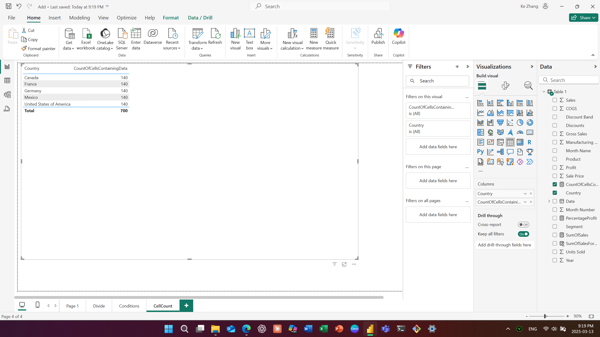

3.5 - Return the Average of All Numbers in a Column

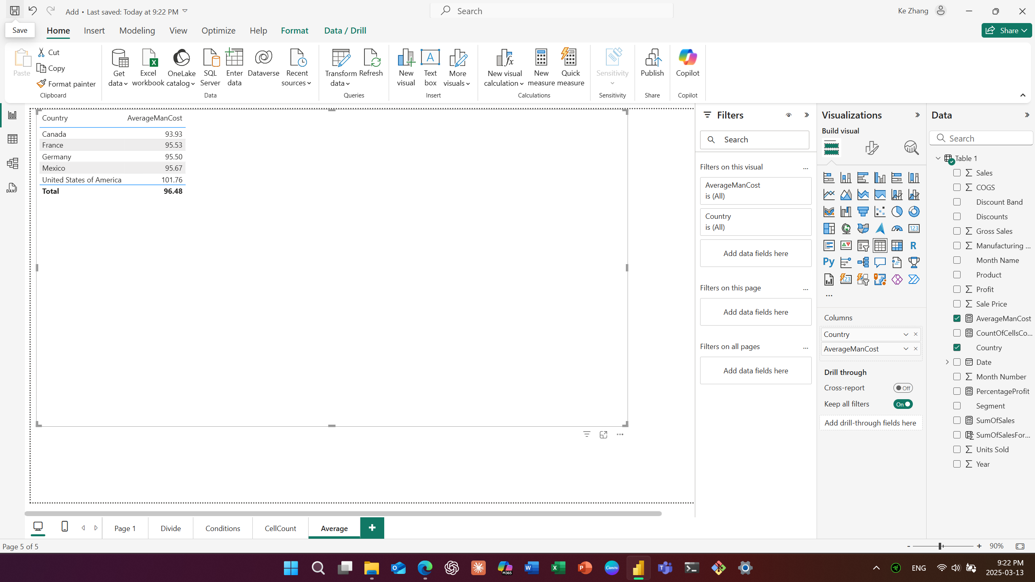

3.6 -Join Two Text Strings into One Text String

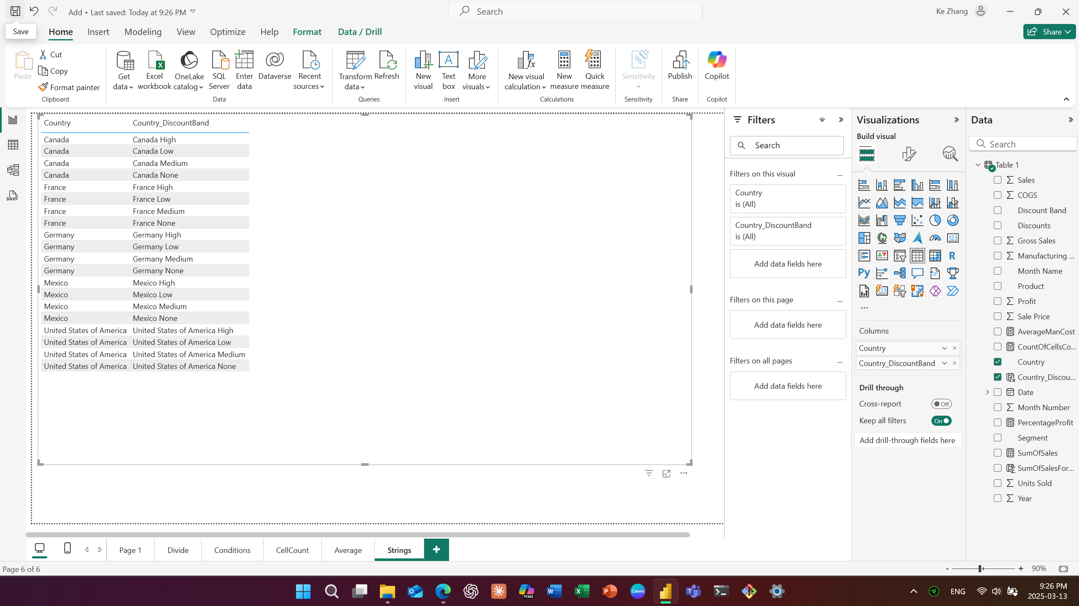

3.7 - Apply conditional Formatting

